OneGMS FSM Data Entry Support Tool
Quick guide: filling the CBPF Field Site Monitoring report and generating the Excel for OneGMS
The tool is a web form that fills the official OneGMS Field Site Monitoring (FSM) Excel template on any device, online or offline. It runs entirely in your browser: nothing is sent to a server, and the file you upload to OneGMS is always the original template with your answers written into it.
Open it at: https://un-ocha.github.io/gms-field-monitoring-form/

Before you start
1. In OneGMS, export the monitoring template for the project (Monitoring-<project>_<date>.xlsx) and save it on the device.
2. Open the tool once while online. After that it works with no connection, and you can add it to the home screen.
3. Decide whether the visit for one project covers one location or multiple locations - you choose this when the report is created. One project excel upload can be used for monitoring same project at multiple locations.

Step 1 — Your reports home
The tool opens on your records home, listing reports saved on this device with their status (draft, complete, generated, uploaded). Reports stay here, so you can reopen and continue one without the original file.
Choose New report to start. Use Export backup regularly — records live only on this device.
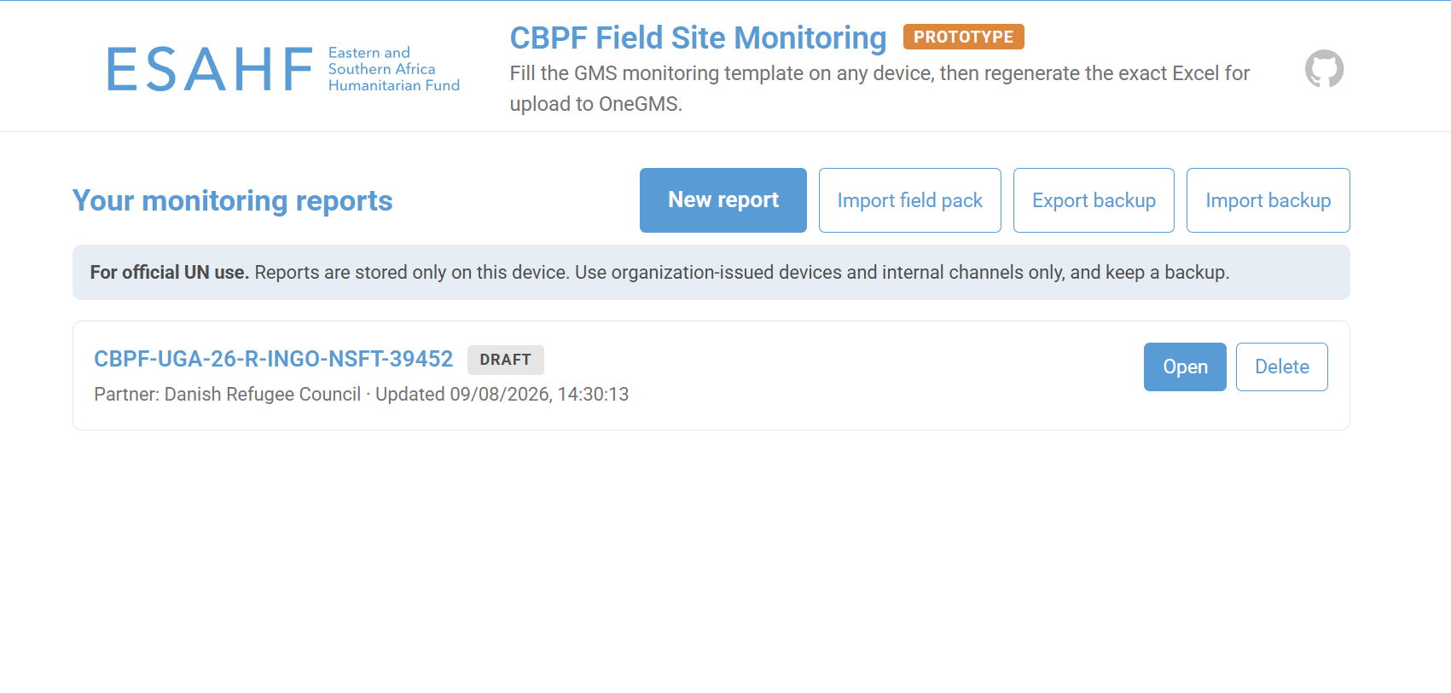
Figure 1 — Reports home: New report, Import field pack, Export / Import backup.

Step 2 — Choose the coverage and load the template
Select one location if the project will be monitored at a single site during the visit, or multiple locations if more than one site will be visited.
Then drop the Monitoring-…xlsx file into the box, or use Choose file. The form, its dropdowns and the project's pre-filled details are all built from the file you load.
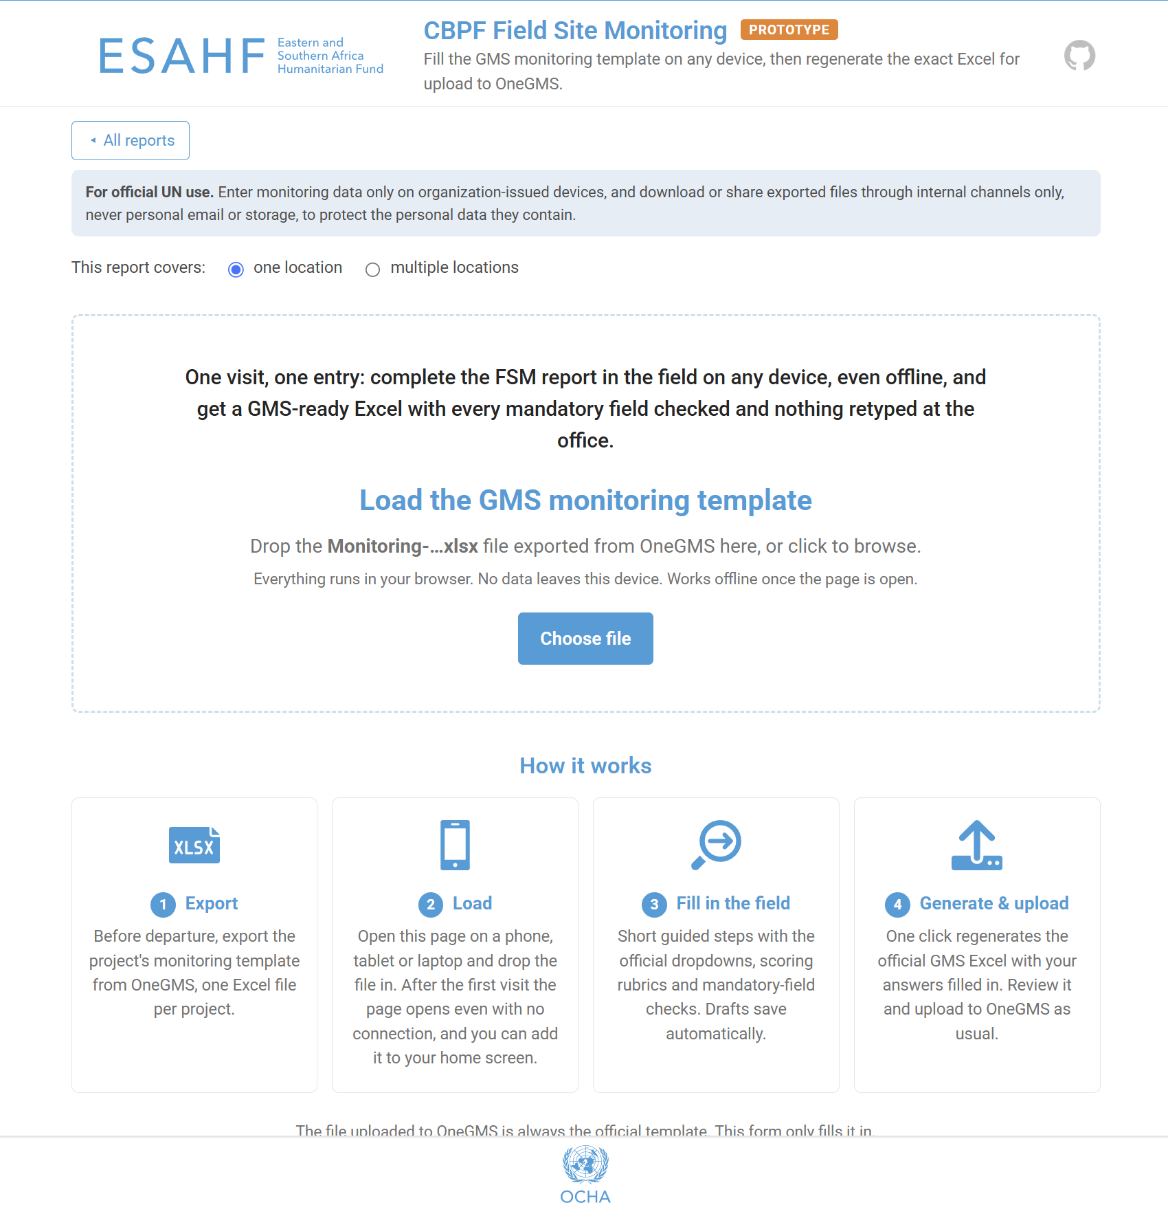
Figure 2 — Coverage selection and template upload.

A. Single-location report
The form opens immediately after the template is loaded.

Fill the form
- The report is split into 5 tabs (General, Implementation, Quality, M&R, Assessment), each with short, guided steps.
- Fields marked * are mandatory. The red badge on each tab shows how many are still outstanding, and the progress bar shows fields filled and mandatory remaining.
- Fields marked pre-filled from GMS come from the template and are read-only.
- Entries autosave on the device as you type. Back and Next move between steps.
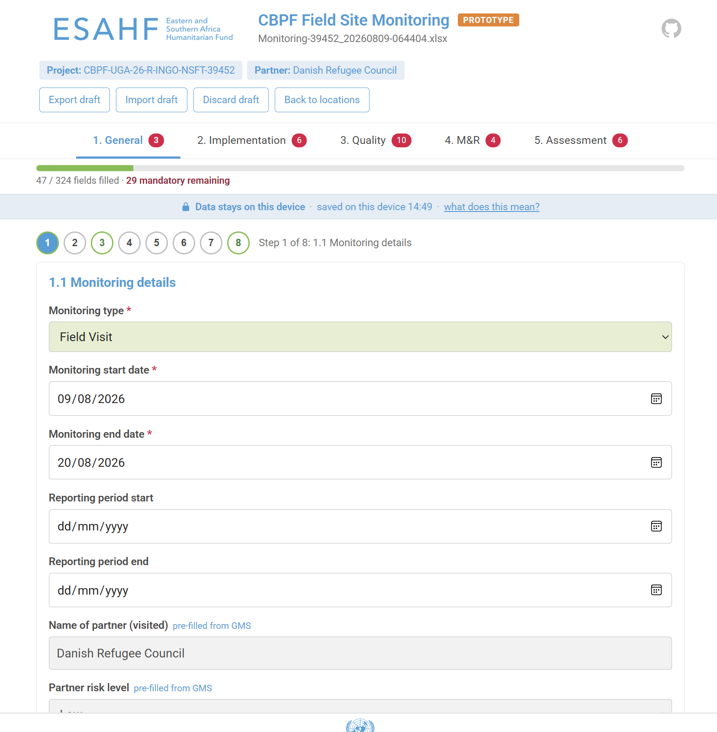
Figure 3 — Form view: tabs, progress bar, mandatory fields and step navigation.

Generate the Excel
Once no mandatory fields remain, Generate Excel for GMS becomes active. It writes your answers into the original template and saves a timestamped copy to the report.
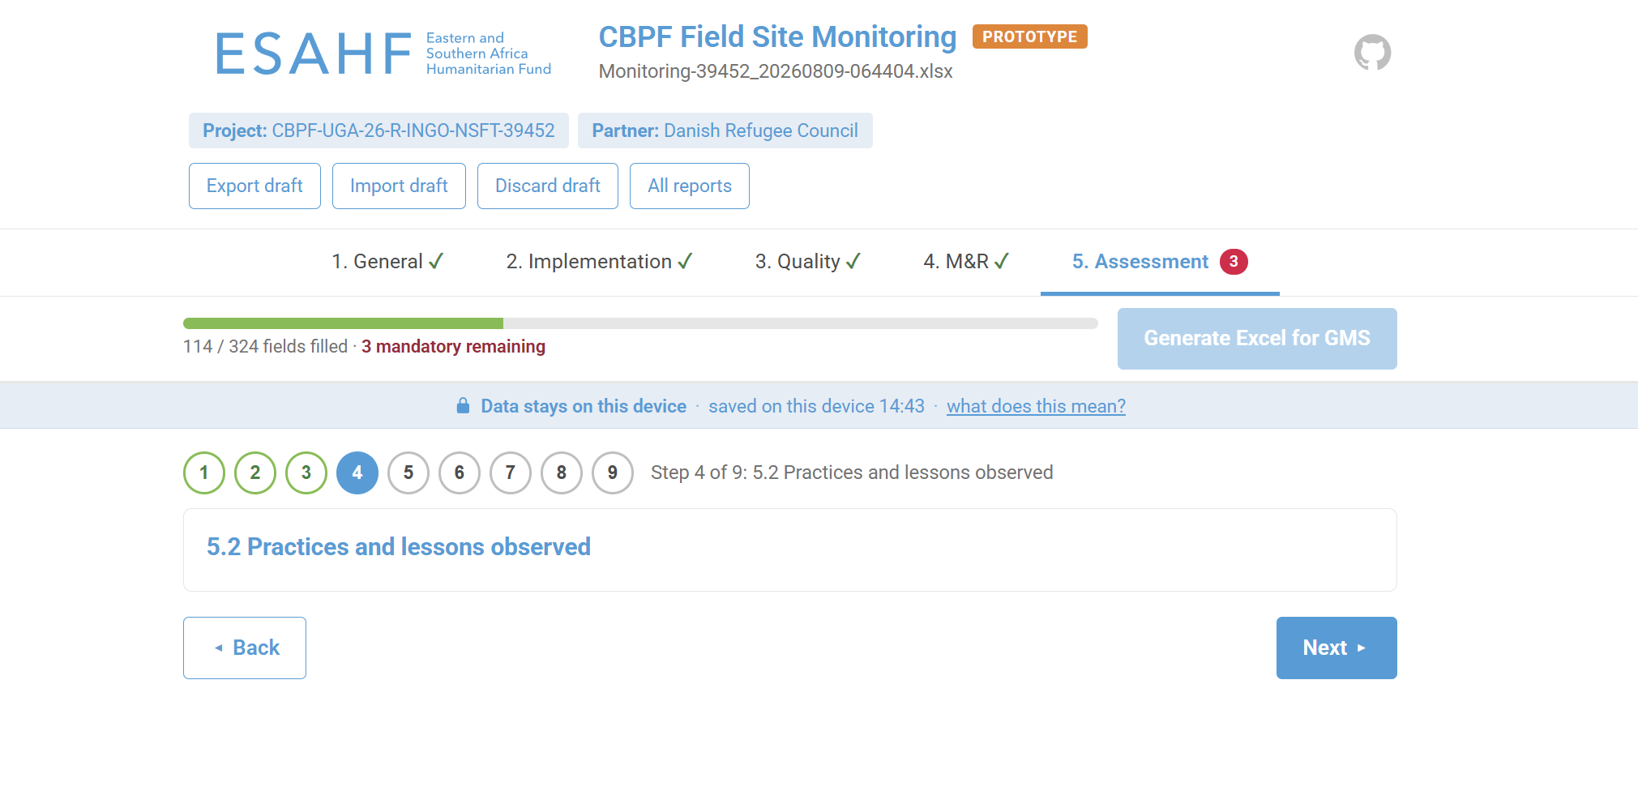
Figure 4 — Generate Excel for GMS (enabled when all mandatory fields are complete).
Open the generated file once in Excel so the score formulas refresh, check it, then upload it to OneGMS as usual.

B. Multiple-location report
When multiple locations is selected and the template is uploaded, the tool opens the project view instead of the form. Add the sites to be visited here; each can be planned ahead of the visit and filled by a different team member on their own device.

Step 1 — Add the locations
Choose Add location and name the site (for example Yumbe). The name identifies the location when entries are merged. Repeat for every site.
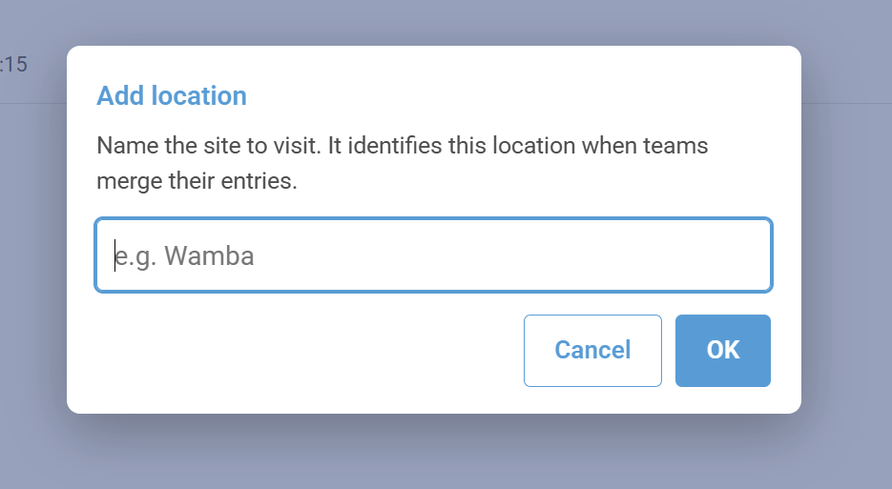
Figure 5 — Add location dialog

Each location appears as a card with its status (planned, draft, complete). Use Open to fill it and Delete to remove it.
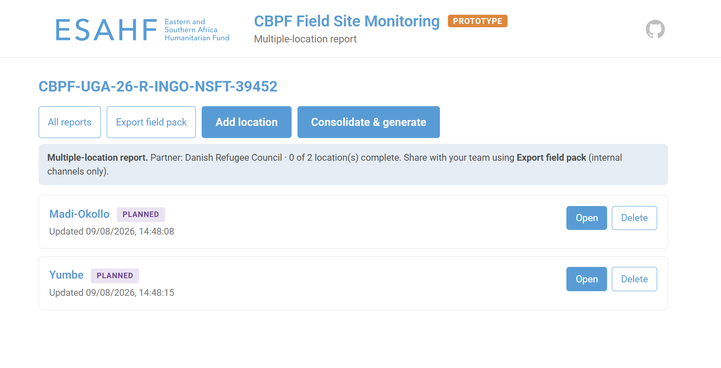
Figure 5 — Project view: locations list, Add location and Consolidate & generate.

Step 2 — Fill each location
Choose Open on a location card. The form is identical to the single-location form (Figure 3); the location name is carried into the visit-location field. Use Back to locations to return to the list.

Step 3 — Split the work across the team (optional)
- Export field pack produces one file holding the project and its locations. Share it with team members through internal channels; a passphrase can be set when exporting.
- Each member uses Import field pack on the reports home, fills their locations, and exports a field pack back.
- Importing merges partial sets cleanly — one person can return two locations and another five, and they still combine into a single report.
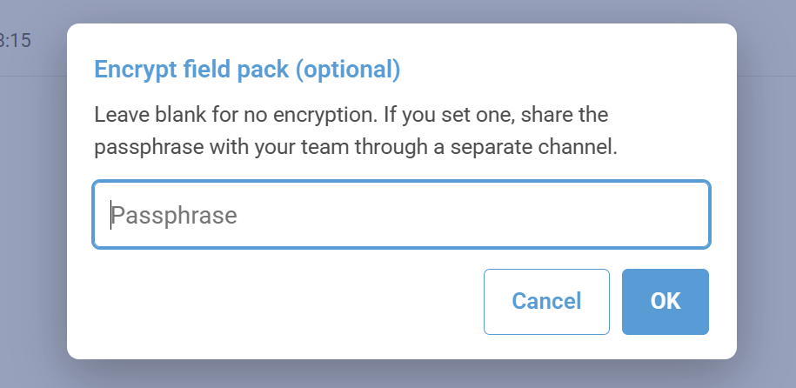

Step 4 — Consolidate and generate
When all locations are complete, choose Consolidate & generate. The tool:
- adds up numbers across locations;
- combines text answers, labelled by location;
- leaves scores for you to set.
It then opens an editable review of the consolidated report. Review and correct everything, set the scores, and generate one final Excel.
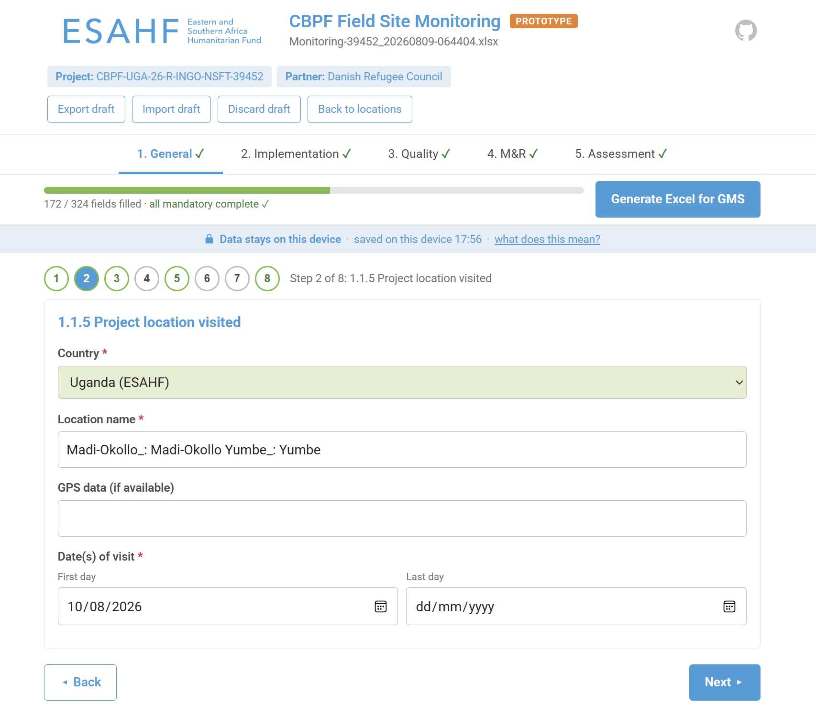
Always review and edit the final Excel before uploading. That review is the quality gate.

Good practice
- Back up. Reports are stored only on the device. Use Export backup after each field day and Export draft before switching device or browser.
- Do not use private / incognito windows — drafts are lost when the window closes.
- Shared computer? Use Discard draft when you finish.
- Handwriting. On a stylus device you can write directly into any text box; tap the ✎ marker on a field for instructions for your device.
- Data protection. Monitoring reports contain personal data (staff and persons-met names, contacts, red-flag findings). Keep them on organization-issued devices when possible, discard from personal devices after compilation and share only through internal UN channels.
- Template changes. If OneGMS changes the FSM template structure, test the tool against the new version before using it in the field.

